An Organized Daily Maktab Program
Focusing on the Spiritual growth of Muslim American Children
Begins:
May 29th
Monday through Thursday
5:15 PM to 6:30 PM
Program Highlights:
Quran, Hadith, Aqa’id, Masa’il, Arabic, Etiquettes and Manner
Scientific Collective System of Teaching
Growing confidence living as Muslim

Where:
9417 102nd St, Ozone Park, NY 11416

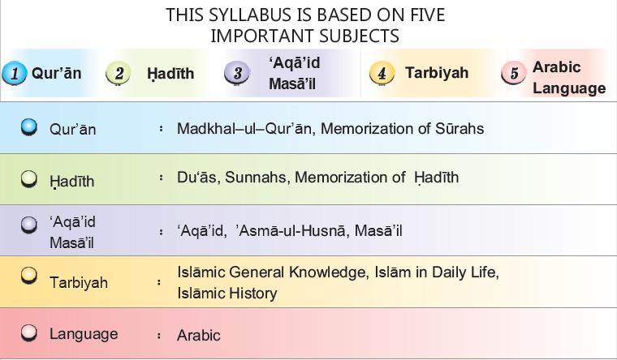
Admission 50$
Free Book and Uniform
Monthly Tuition 65$
Last date for admission
June 29th
Lessons are divided into Days and months. Parents have to sign after each lesson.
Questions/Registration
Call/Text Sheikh Zafar # 929-355-1202

Daily Organized Maktab
Praising Allah & Prophet ﷺ | Hamd  and  Naat | Poems Praising Allah and Poems Praising the Prophet ﷺ
Quran | Qaidah | Rules of Tajweed
 | Nazirah | Naazirah of whole Quran with Tajweed
 | Surah Memorization | Portion of Juz Ammah, Yaseen, Kahf, Mulk, Sajdah, Waqiyah, Ar-Rahman
Hadith | Dua | 100 Masnun Duas (Recited by our Prophet ﷺ) for different occasions
 | Sunnah Etiquettes | 13 Sunnah Etiquettes of daily life like; eating, drinking, sleeping, dreams etc.
 | Hadith Memorization | 50 Hadith on Iman, Ibadah, Mu’amalah, Mu’asharah, and Akhlaq
Aqa’id & Masa’il | Aqa’id | All the Kalimas and Components of Islam like; Oneness of Allah, Divine Books, Prophets, Angels, Fate, Hereafter etc.
 | Slalah/Wudu | Sunnah method of Salah and Wudu with application
 | Asma’ul-Husna | 99 Beautiful Names of Allah
 | Masa’il | Related to cleanliness Taharah, Salah, Zakah, Saum and Haj
Tarbiyah Islamic Upbringing | Islamic Knowledge | 110 questions and answers regarding important Islamic facts
 | Islamic History | Life of Rasulullah ﷺ and the four rightly guided Khulafa Rashideen
 | Speeches | Islamic speeches on the five branches of Islam; Iman, Ibadah, Mu’amalah, Mu’asharah and Akhlaq
 | Islam in Daily Life | Applying the Hadith memorized in to personal life while building good traits such as; Faith, Worship, Good Dealings, Good Behavior and Good Character
Arabic | Numbers | 1-100 (memorize Arabic numbers from one to one hundred)
 | Words | 5,000 (memorize five thousand Arabic words)
 | Sentences | 30 Arabic dialogues

